DEV-03: Feature Importance and Explainability

1. Overview
A prediction is only useful to the registrar if it can be explained: why does this request need 12 days and that one 3? Linear regression makes this direct, because each prediction is a sum of one contribution per feature. Three explainability methods are used:
- Standardized coefficients: how many days a feature adds for a typical change in it, so features measured in different units can be compared.
- Permutation importance: how much worse the model gets on the test set when one feature is shuffled at random. This measures how much the model actually relies on each feature.
- Per-prediction breakdown: for one request, the days each of its inputs adds. The registrar sees this on the Predictions page (DEV-05).
The model is trained on simulated data (DEV-01), so these results show what the model learned from the simulation. Retrained on pilot requests, the same charts will show the real bottlenecks, which is Chapter 1, Objective 3.

2. Permutation Importance
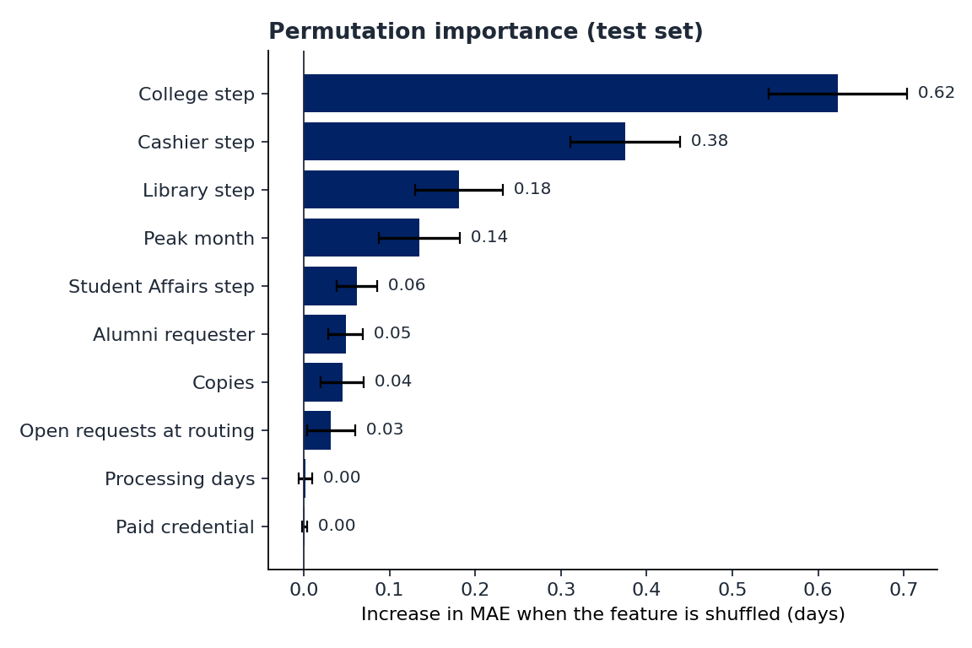
Figure 1. Permutation importance on the test set (20 repeats; bars show the mean, whiskers one standard deviation)

3. Standardized Coefficients
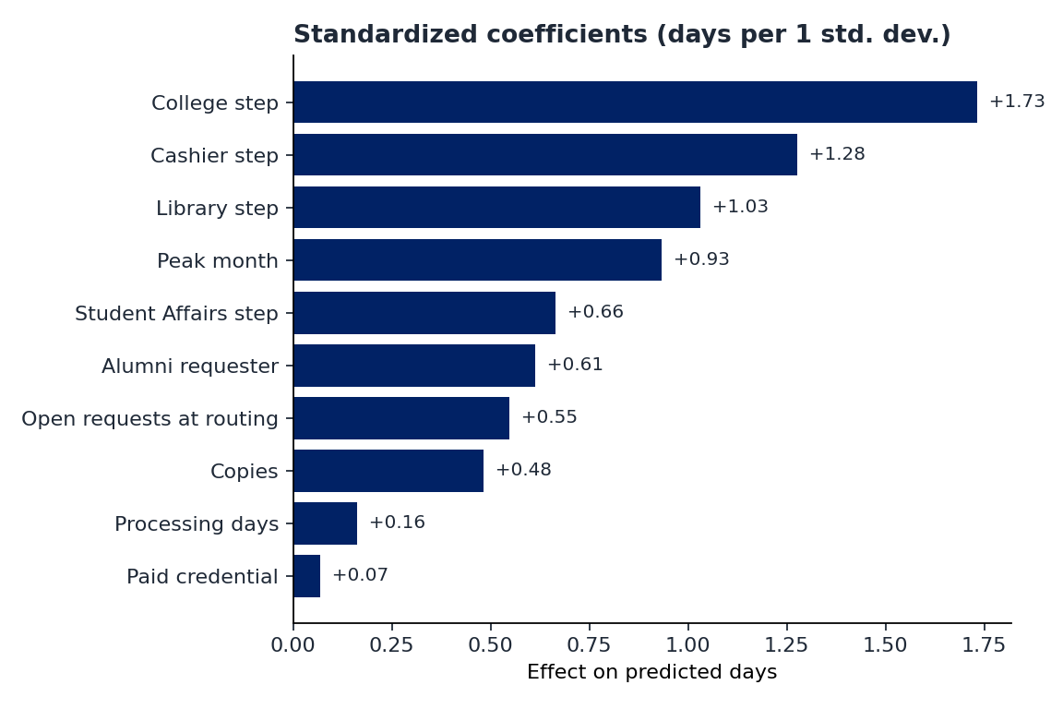
Figure 2. Standardized coefficients: days added for a one-standard-deviation increase in each feature
All coefficients are positive: every input makes a request take longer, which matches how the process works (more offices, more copies, busier periods).

4. Which Features Have the Greatest Influence?
Table 1. Features ranked by permutation importance
Rank | Feature | Importance (days of MAE) | Std. coefficient | Interpretation
1 | College step | +0.623 | 1.733 | The college's academic verification is the slowest step and the main driver
2 | Cashier step | +0.375 | 1.276 | Financial clearance is slow and holds requests most often
3 | Library step | +0.181 | 1.031 | Library clearance adds time and frequent holds (unreturned books)
4 | Peak month | +0.135 | 0.932 | Graduation and enrollment season slows every office
5 | Student Affairs step | +0.062 | 0.664 | Conduct verification adds a smaller, steadier delay
6 | Alumni requester | +0.049 | 0.613 | Archived records of alumni take longer to retrieve
7 | Copies | +0.045 | 0.483 | Each extra copy adds printing and certification time
8 | Open requests at routing | +0.032 | 0.548 | More open requests slow every office a little
9 | Processing days | +0.002 | 0.161 | Little extra information once the offices are known
10 | Paid credential | +0.001 | 0.069 | Little extra information; paid credentials already include the Cashier step

Answer: the features with the greatest influence are whether the student's college signs, whether the Cashier signs, whether the Library signs, and whether the request is routed in a peak month. In plain terms, the offices in a credential's signing order and the time of year decide most of the turnaround. Copies, alumni status and the current workload matter, but less.
Processing days and payment add almost nothing. They are not useless; they are redundant, because they are tied to credential types whose offices the model already knows. This is why permutation importance and coefficients are read together.

5. Explaining One Prediction
The registrar's question is usually about one request. For the Transcript of Records example in DEV-02 (2 copies, alumnus, 20 open requests, normal month), the model adds the contributions below:
Table 2. Contribution of each input to a 12.4-day prediction
Input | Value | Days added
College step | 1 | +3.54
Cashier step | 1 | +2.57
Library step | 1 | +2.14
Open requests at routing | 20 | +1.42
Alumni requester | 1 | +1.23
Copies | 2 | +0.77
Processing days | 10 | +0.56
Paid credential | 1 | +0.14
Intercept (base) |  | +0.05
Predicted turnaround |  | 12.4 days

So the college step, the Cashier and the Library account for about 8 of the 12.4 days, which tells the registrar where to follow up if this request starts to slip. The Predictions page shows the same breakdown as a bar list for any request profile.

6. How to Reproduce
python ml/train.py
# charts: ml/output/permutation_importance.png, ml/output/coefficients.png
# numbers: ml/output/metrics.json (standardized_coefficients, permutation_importance)

